NAME: B GOWTHAM
REG NO. :192512104
MONITORING HTTP AND HTTPS PACKET USINF WIRESHARK
OBJECTIVE 1
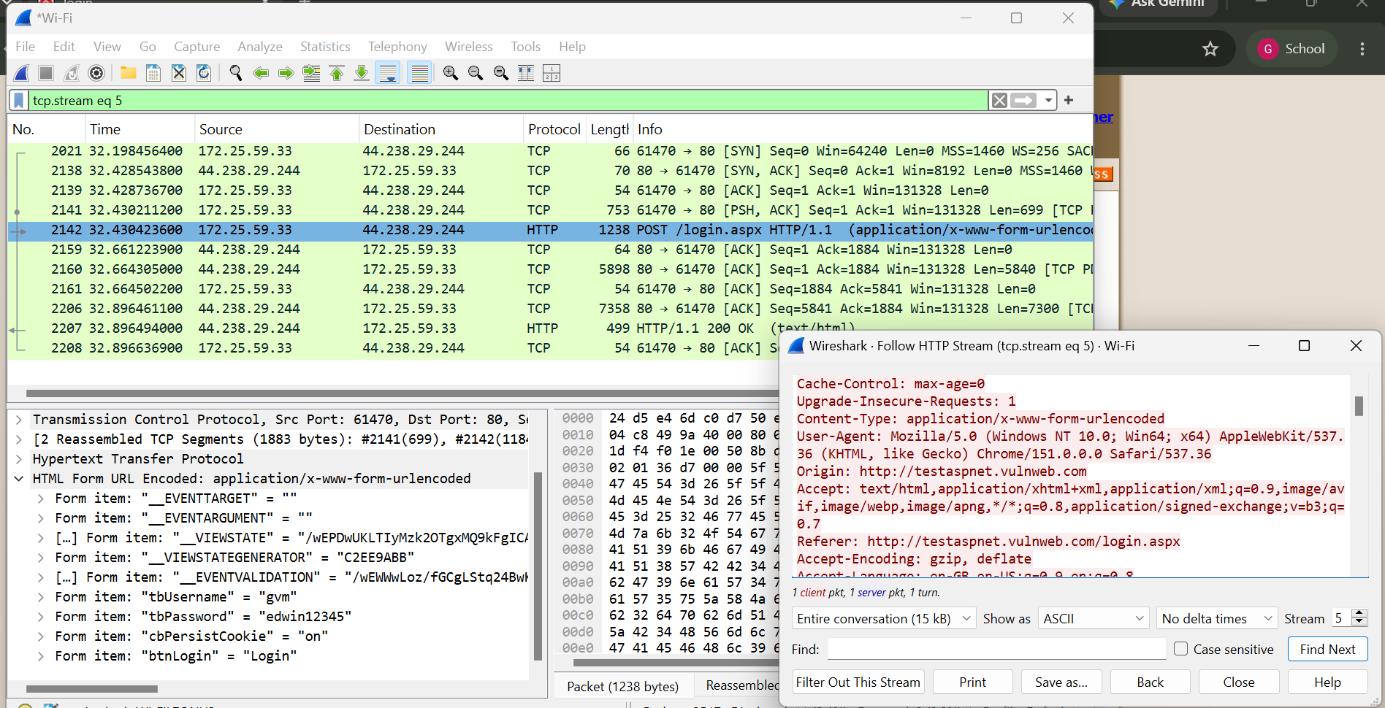
OBJECTIVE 2
